Prep
The Farmer in the Dell – Sing and add a beat action
https://www.bing.com/videos/search?q=The+farmer+in+the+Dell&&view=detail&mid=400F5539D26EDCE915B9400F5539D26EDCE915B9&&FORM=VRDGAR&ru=%2Fvideos%2Fsearch%3Fq%3DThe%2Bfarmer%2Bin%2Bthe%2BDell%26FORM%3DHDRSC3

Clap |  | Stamp |  | 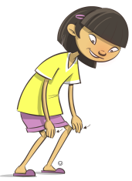  Tap
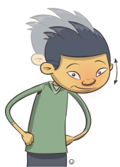  Nod |  | 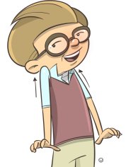  Shrug |  | 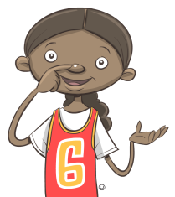  Point
Flap |  | 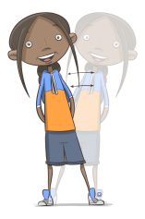  Sway |  | 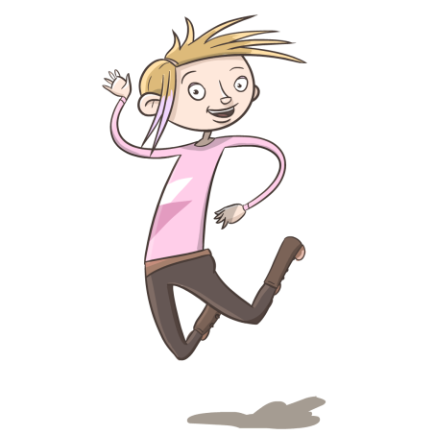  Jump
Year 1
Activity:
- Sing Charlie over the Ocean https://www.bing.com/videos/search?q=Charlie+over+the+Ocean&view=detail&mid=D309AA61E3FD92A72CD9D309AA61E3FD92A72CD9&FORM=VIRE0&ru=%2fsearch%3fq%3dCharlie%2bover%2bthe%2bOcean%26src%3dIE-SearchBox%26FORM%3dIESR3N
- Do the beat on an instrument from home (eg. Tambourine/maracas/little drum) while you sing
- Change the words and make your own song: Eg.
Charlie Sarah over the Ocean
Charlie Sarah over the Sea
Charlie Sarah caught a big fish starfish
Can’t catch me!

Year 2
Activities:
- Sing Frere Jacque and Brother John
https://www.bing.com/videos/search?q=Frere+Jacque+english+version&&view=detail&mid=D8D1CF1B99655F7F91DAD8D1CF1B99655F7F91DA&&FORM=VRDGAR&ru=%2Fvideos%2Fsearch%3Fq%3DFrere%2BJacque%2Benglish%2Bversion%26FORM%3DHDRSC3

https://www.bing.com/videos/search?q=Frere+Jacque+english+version&ru=%2fvideos%2fsearch%3fq%3dFrere%2bJacque%2benglish%2bversion%26FORM%3dHDRSC3&view=detail&mid=D37DE0A852F9B17897BCD37DE0A852F9B17897BC&&FORM=VDRVRV
- Change the lyrics and make a song about saving the world.
Example
- Lyrics and dynamics
Water and soil  p | Water and soil  f
Grow our food  p | Grow our food  f
Turn off all the dripping taps  p | Save our water for the plants  p
Drip, drip drop,  p | Save every drop.  f

Year 3
- Sing the chorus with the Scottish song Maire’s Wedding
https://www.youtube.com/watch?v=xwqU3YGBUgY
Mairi’s wedding
Mairi’s wedding is a song from the Orkney Islands in Scotland.
Mary McNiven was a famous singer and her friend, Johnny Bannernan, composed the words for her in 1935. The tune is also known as the Lewes bridal tune.
- Make a repeated rhythm and sing the chorus and play the rhythm with it!

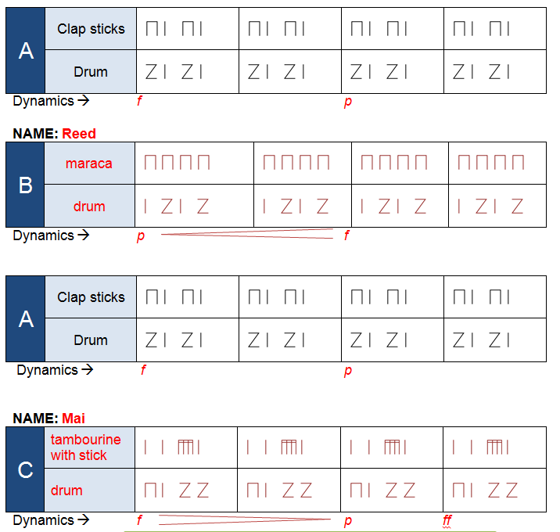

Years 5/6
Activities:
- Make a guitar
https://www.youtube.com/watch?v=XqY9JqKdvBU
- Practise chords A, D and E on homemade guitar (6 Strings)
https://www.youtube.com/watch?v=VkkOFLouQDs
https://www.youtube.com/watch?v=yh6sPqDEZCY
https://www.youtube.com/watch?v=8H393ryDkuY
- GarageBand app – play the chords
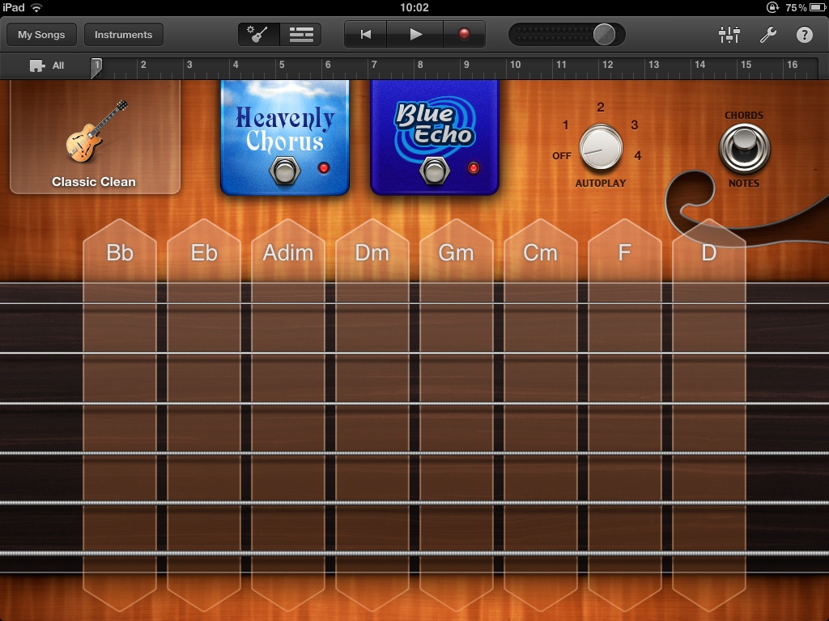
- Play the Chord Progression: A D A E

